# Report for Caden Halligan (2024-10-01 to 2024-10-31)

Average Bat Speed: 49.20

Average Rotational Acceleration: 10.25

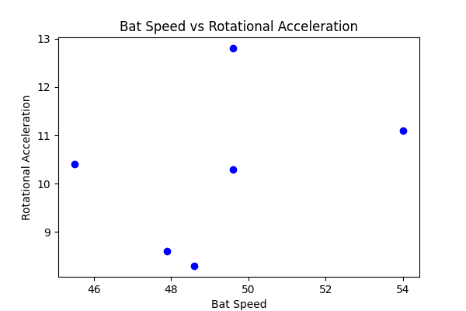

## Comments

Add comments here...